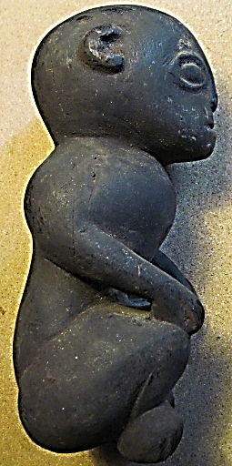 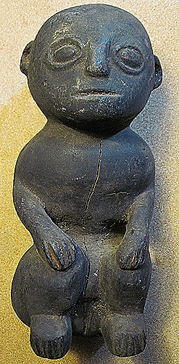 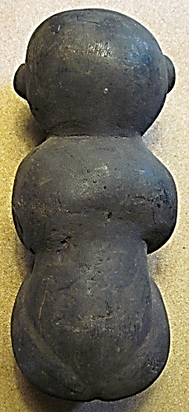 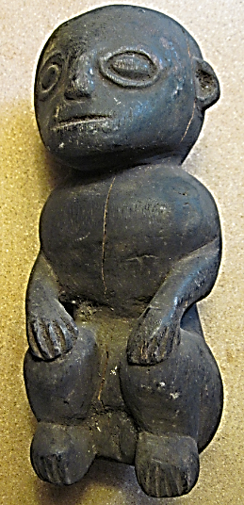

Figs 1-4. Philippines-Ifugao-Igorot-Bulul Figure-Androgynous-Wood-15th cent.

**Case no.:**

**Accession Number: A000**

**Formal Label:** Philippines-Ifugao-Igorot-Bulul Figure-Androgynous-Wood-15th cent.**Display Description:**

Northern Luzon’s central cordillera is home to indigenous communities called the Ifugao or Igorot whose self-determination and geographic isolation helped protect them from Spanish colonization. The term "Ifugao" or "*ipugo*" means "earth people," "humans," as distinguished from sky-dwelling spirits and deities. However, the Austronesian term "Igorot" ("mountain people") is more correct an appellation, as these people are all Austronesian speakers. Furthermore, the Igorot divide themselves into two subgroups: a rice terrace-farming group in the south, central and western areas, and a smaller group in the east and north (Ember and Ember 2003: 498). These two Igorot groups may be further subdivided into five Igorot ethnolinguistic groups: Bontoc, Ibaloi, Isnag, Kalinga, and the Kankanaey (Anon. 2015)

Igorot cosmology views each village with its own axis mundi, a central stone platform linking it to the deities above. This central platform provides the focus for social and spiritual rituals, including the worship of deities and ancestors and the consecration of sculptural figures like this one. Kiyyangan is considered the birthplace of the Igorot people and Hungduan as the epicenter of its culture.

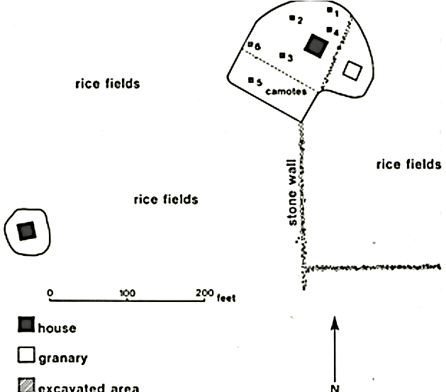

Fig. 5. Kiyyangan village excavations. From (Maher 1984).

The most important of Igorot figurative sculptures are the *bulul*. These are standing or seated wooden figures carved from a single piece of hard wood with a formalized representation of the human body with folded arms and with hands resting on their knees. Often they are carved in male and female pairs, but this figure is solo and appears to be androgynous. *Bulul* are frequently placed in rice fields and granaries as guardians but not before they are ritually consecrated. This is accomplished during a *buni* or ritual dance and *bubud* (a rice liquor) drinking ceremony followed by the sacrificial slaughter of a pig and by coating the *bulul* figure with its blood, the essence of life, which imparts a consistently dark patina like this one (Willcox 1912: 112).

**LC Classification:** DS666.I15

**Date or Time Horizon:** 15th century

**Geographical Area:** Hungduan, Luzon, Philppines

**Map:**

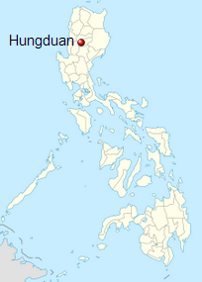

Fig. 6. Location of Hungduan in Luzon, Philippines. From https://upload.wikimedia.org/wikipedia/commons/thumb/a/ad/Philippines_location_map_%28square%29.svg/375px-Philippines_location_map_%28square%29.svg.png

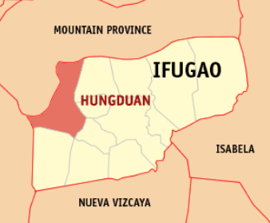

Fig. 7. Location of Hungduan village in its surrounding area. From https://upload.wikimedia.org/wikipedia/commons/e/eb/Ph_locator_ifugao_hungduan.png

**GPS coordinates:** [16°50′N 121°00′E](https://tools.wmflabs.org/geohack/geohack.php?pagename=Hungduan,_Ifugao&params=16.83_N_121_E_region:PH_type:city%289400%29)

**Cultural Affiliation:** Ifugao, Igorot

**Media:** wood, swine blood

**Dimensions:** H 25.4 cm, 10 in

**Weight: 853 g, 1 lb 14 oz**

**Condition: original**

**Provenance:** old Spanish collection

**Discussion:**

The Igorot developed one of the most sophisticated and prosperous plutocracies in the Philippine archipelago, and, with Kalinga, it was one of the two most important plutocracies in Luzon.

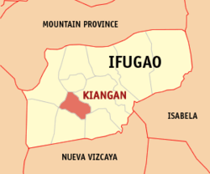

Fig. 8. Location of Kiangan (inside of which is Kiyyangan) in its surrounding area. From <https://upload.wikimedia.org/wikipedia/commons/c/c5/Ph_locator_ifugao_kiangan.png>

Kiyyangan is considered the most ancient village of the Igorot and the birthplace of the Igorot people where their mythological ancestors Wigan and Bugan had originated. However, the TL (thermoluminescent) dating of excavated pottery from the site is from the 13th century CE, so that earlier remains must have been obliterated with each succeeding occupation (Maher 1984: 127).

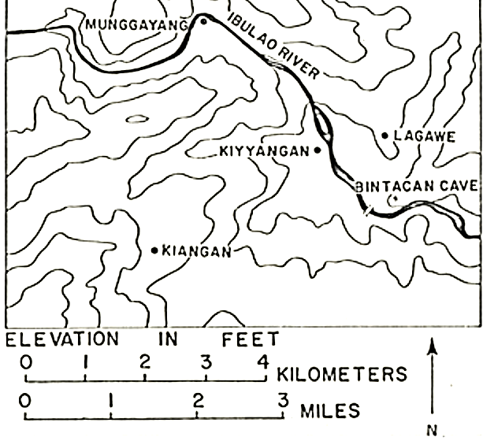

Fig. 9. Location of Kiyyangan. From (Maher 1984).

The country of the Igorot in the southeastern part of the Cordillera region are known for their Banaue Rice Terraces that were first constructed about 500 BCE and are among the most efficient agricultural technologies of volcanic islands in the western Pacific. These terraces are where the *bulul* are placed, so that sometimes the *bulul* become submerged in the soil due to erosion of the terraces and become exposed only years later with further erosion, like the current example and this is why it is in such good shape.

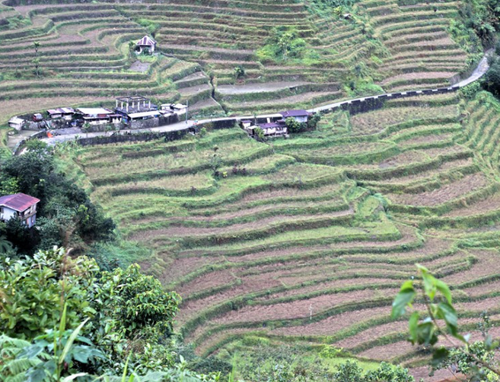 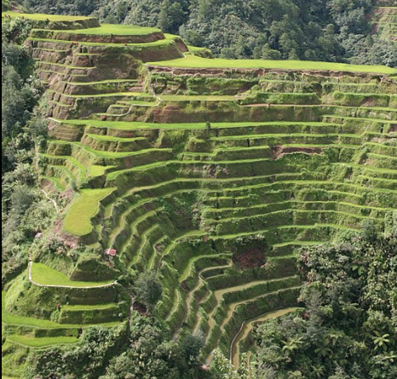

Fig. 10. Banaue rice terraces (N. Luzon, Philippines). From <https://i2.wp.com/harrybalais.com/wp-content/uploads/2014/10/Hungduan-Rice-Terraces-01.jpg?resize=1024%2C683>

Fig. 11. Banaue rice terraces (N. Luzon, Philippines) taken from the observation point at beginning of road to Bontoc. Clear evidence of erosion of the terraces. From https://upload.wikimedia.org/wikipedia/commons/thumb/c/cc/Banaue-terrace.JPG/1200px-Banaue-terrace.JPG

The Igorot villages are ruled not by monarchs but by a council of elders which continued a peaceful and prosperous plutocracy that resolved conflicts among the Igorot people and the lowland settlers or Ilokanos.

**References:**

Anon. 2015. http://sagada-igorot.blogspot.com/2007/12/igorot-ethnic-groups.html

Ember, Carol R. and Melvin Ember. 2003. [*Encyclopedia of sex and gender: men and women in the world's cultures*, Volume 1](https://books.google.com/books?id=XUAsskBg8ywC&lpg=PA498&dq=Ifugao&pg=PA498#v=onepage&q=Ifugao&f=false). London: Springer.

Maher, Robert F. 1984. “Kiyyanga village of Ifugao Province, Philippines,” *Philippine Quarterly of Culture and Society*, 12(2): 116-127.

Willcox, Cornélis De Witt. 1912. *The head hunters of northern Luzon: from Ifugao to Kalinga, a ride through the mountains of northern Luzon: with an appendix on the independence of the Philippines.* New York: Franklin Hudson Publishing Co.